ADO.NET

The full form of ADO is ActiveX Data Object. ADO.NET provides a bridge between the front-end controls and the back-end database. The ADO.NET objects encapsulate all the data access operations and the controls interact with these objects to display data.

DO.NET is an object-oriented set of libraries that allows you to interact with data sources. Commonly, the data source is a database, but it could also be a text file, an Excel spreadsheet, or an XML file.

Data Providers

ADO.NET provides a relatively common way to interact with data sources but comes in different sets of libraries for each way you can communicate to a data source. These libraries are called Data Providers and are usually named for the protocol or data source type they allow you to interact with.

Table 1 lists some well-known data providers, the API prefix they use, and the type of data source they allow you to interact with.

|  |  |  |
| --- | --- | --- |
| Provider Name | API prefix | Data Source Description |
| ODBC Data Provider | Odbc | Data Sources with an ODBC interface. Normally older databases. |
| OleDb Data Provider | OleDb | Data Sources that expose an OleDb interface, i.e., Access or Excel. |
| Oracle Data Provider | Oracle | For Oracle Databases. |
| SQL Data Provider | SQL | For interacting with Microsoft SQL Server. |

ADO.NET Architecture

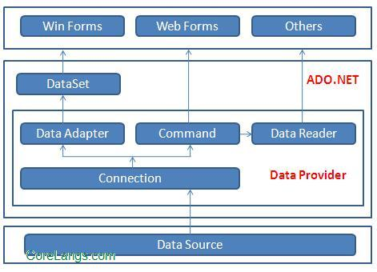

ADO.NET consist of a set of Objects that expose data access services to the .NET environment. It is a data access technology from Microsoft .Net Framework, which provides communication between relational and non-relational systems through a common set of components.

System.Data namespace is the core of ADO.NET and it contains classes used by all data providers. ADO.NET is designed to be easy to use, and Visual Studio provides several wizards and other features that you can use to generate ADO.NET data access code.

Data Providers and DataSet

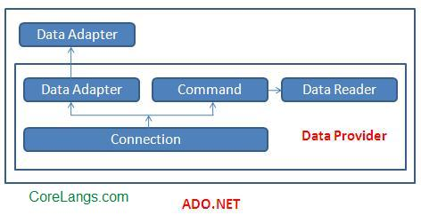

The two key components of ADO.NET are Data Providers and DataSet. The Data Provider classes are meant to work with different kinds of data sources. They are used to perform all data-management operations on specific databases. DataSet class provides mechanisms for managing data when it is disconnected from the data source.

Data Providers

The .Net Framework includes mainly three Data Providers for ADO.NET. They are the Microsoft SQL Server Data Provider, OLEDB Data Provider and ODBC Data Provider. SQL Server uses the SqlConnection object, OLEDB uses the OleDbConnection Object and ODBC uses OdbcConnection Object respectively.

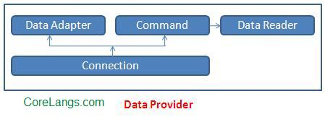

A data provider contains Connection, Command, DataAdapter, and DataReader objects. These four objects provide the functionality of Data Providers in the ADO.NET.

Connection

The Connection Object provides physical connection to the Data Source. Connection object needs the necessary information to recognize the data source and to log on to it properly, this information is provided through a connection string.

Command

The Command Object uses to perform SQL statement or stored procedure to be executed at the Data Source. The command object provides a number of Execute methods that can be used to perform the SQL queries in a variety of fashions.

DataReader

The DataReader Object is a stream-based, forward-only, read-only retrieval of query results from the Data Source, which do not update the data. DataReader requires a live connection with the databse and provides a very intelligent way of consuming all or part of the result set.

DataAdapter

DataAdapter Object populate a Dataset Object with results from a Data Source . It is a special class whose purpose is to bridge the gap between the disconnected Dataset objects and the physical data source.

DataSet

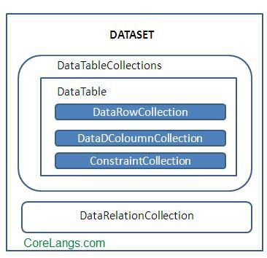

DataSet provides a disconnected representation of result sets from the Data Source, and it is completely independent from the Data Source. DataSet provides much greater flexibility when dealing with related Result Sets.

DataSet contains rows, columns,primary keys, constraints, and relations with other DataTable objects. It consists of a collection of DataTable objects that you can relate to each other with DataRelation objects. The DataAdapter Object provides a bridge between the DataSet and the Data Source.